**Project Design Phase-II**

**Data Flow Diagram & User Stories**

|  |  |
| --- | --- |
| Date | 22 June 2025 |
| Team ID | LTVIP2025TMID40098 |
| Project Name | Pollen's Profiling: Automated Classification of Pollen Grains |
| Maximum Marks | 4 Marks |

**Data Flow Diagrams:**

**Pollen's Profiling: Automated Classification of Pollen Grains**

using transfer learning to detect pollen grains. It outlines the key components—image input, preprocessing, feature extraction via a pre-trained CNN (like VGG16), classification, and actionable sorting decisions.

Let me know if you'd like the diagram to emphasize any particular aspect, such as integration with Flask or front-end feedback loops!

**Example: DFD Level 0 for pollen grains**

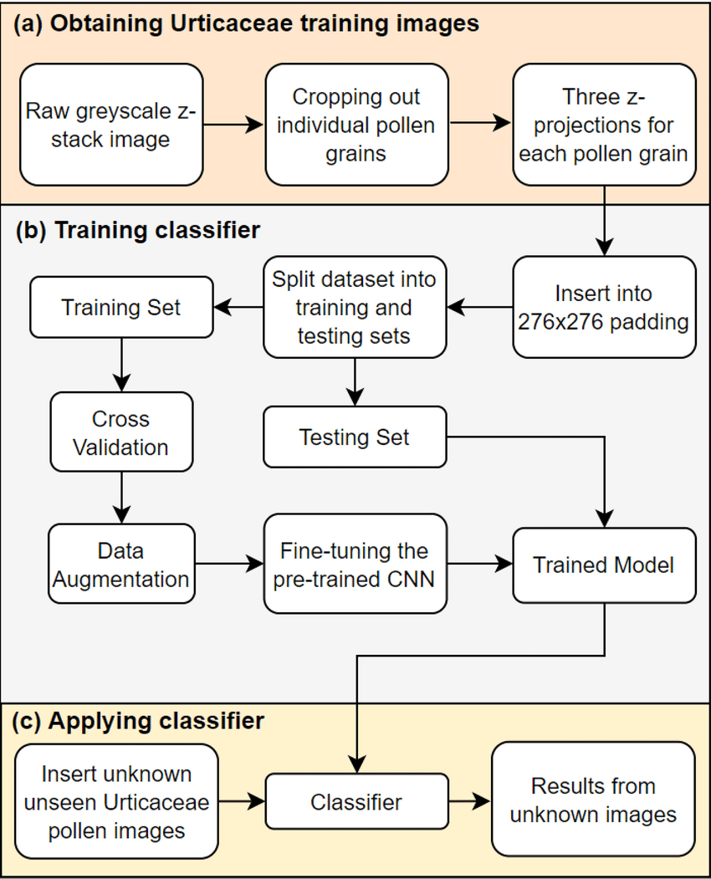

**User Stories for Pollen Grains Classification System**

|  |  |  |  |  |  |  |
| --- | --- | --- | --- | --- | --- | --- |
| **User Type** | **Epic** | **Story #** | **User Story** | **Acceptance Criteria** | **Priority** | **Release** |
| Researcher/Botanist | Registration | PG-US-1 | As a researcher, I can register using my email and password. | Can log in successfully after registration. | High | Sprint-1 |
| Researcher/Botanist | Image Upload | PG-US-2 | As a user, I can upload microscopic images of pollen grains for classification. | System accepts and confirms image upload. | High | Sprint-2 |
| Researcher/Botanist | Prediction | PG-US-3 | As a user, I can view the predicted pollen type and its confidence score. | System displays label and confidence after classification. | High | Sprint-2 |
| Researcher/Botanist | View History | PG-US-4 | As a user, I can view the history of previous image uploads and results. | Records show image, date, and prediction outcome. | Medium | Sprint-3 |
| Admin | Manage Users | PG-US-5 | As an admin, I can view, edit, or delete registered users. | Admin dashboard lists users with view/edit/delete options. | Medium | Sprint-3 |
| Admin | Model Feedback & Tuning | PG-US-6 | As an admin, I can review user feedback and retrain the classification model. | Can access feedback logs and initiate model retraining process. | High | Sprint-4 |